
Rosebank cOLLEGE Xisd TASK 1
PROJECT PLAN, SITE MAP & WIREFRAMES

Group Members | ST10399907 Phungo Tshiredo  ST10188776 Mabuza Tebogo  ST10449154 Mbuso Sbusiso Dube  ST10437200 Nkosikhona Dlamini  ST10291289 Kagiso Twala
Lecturer | [Lecturer Name]
Submission Date | [2026/09/04]

Table of Contents

PROJECT PLAN 3
Name: Mamelodi Initiative 3
Logo: 3
Introduction 3
Project Overview 3
Project Objectives 4
Project Scope 5
Project Deliverables 5
Team Roles and Responsibilities 7
Proposed Project Schedule 8
Development approach 8
DevOps Life Cycle 9
Project Resources 10
Risk Management 10
PROJECT DESIGN 11
ANDROID MOBILE SITEMAP 11
WEBSITE SITEMAP 12
ANDROID MOBILE WIREFRAMES 13
WEBSITE WIREFRAMES 14
References 17

List of figures

Figure 1 Mobile Application Sitemap 11
Figure 2 Website Sitemap 12
Figure 3 Home & Programs screens 13
Figure 4 Volunteer & News screens 13
Figure 5 More options (About, Donate & Contact) screen 14
Figure 6 Home Page 14
Figure 7 Programs Page 15
Figure 8 About Us Page 15
Figure 9 News page 16
Figure 10 Contact us Page 16

PROJECT PLAN

Name: Mamelodi Initiative

GitHub Link: https://github.com/TEBOG0-M/Mamelodi-Initiative-


Logo:

Introduction
The Mamelodi initiative is a not-for-profit organization with one major goal in mind ,the liberation of academic pressure caused by finances. We strive to help the younger generation have access to a better future and a persistent one at that, and you might be wondering why well that’s simply because education is an important aspect when it comes to nurturing the younger generation and ensuring that they have the resources required to make a real difference.

Project Overview

The Mamelodi Initiative is a non-profit organization that works to support and empower young people in Mamelodi through educational opportunities and programs. The proposed system will provide a digital platform to support the organization’s fundraising efforts and establish a stronger connection between the organization and its donors.
The system will aim to make it easier for donors to contribute to the organization, access relevant information, and remain engaged with the organization over time. The system will consist of both a website and a mobile application.
The project will involve UI/UX design, planning, development, testing, and deployment of the proposed system.

Project Objectives

- Provide a user-friendly experience for donors
- Make the website and mobile application simple, clear, and easy to navigate.
- Provide information about the organization
- Give users information about the Mamelodi Initiative, its purpose, activities, and programs.
- Provide transparency about donations
- Explain why donations are needed and how donated funds may be used to support the organization.
- Improve donor engagement
- Keep donors informed about the organization’s current activities, progress, and achievements through news and updates.
- Separate donor and volunteer activities
- Provide separate sections for users who want to donate and users who want to volunteer.
- Provide a volunteer application system
    - Allow interested individuals to access information and submit their details to volunteer with the organization.
- Provide an accessible donation system
    - Make it easy for users to find donation information and contribute to the organization.
- Provide information about the organization’s programs
    - Allow users to view the different programs offered by the Mamelodi Initiative and understand their purpose.
- Improve communication with users
    - Provide relevant news, announcements, and updates so that donors, volunteers, and other users can stay informed.
- Strengthening the relationship between the organization and its supporters
- Create a central platform where donors and volunteers can regularly interact with the organization and learn about its ongoing work.

Project Scope
The proposed system will consist of a website and mobile application designed to improve the interaction between the Mamelodi Initiative and its donors, volunteers, and other users. The system will provide users with information about the organization, its programs, volunteer opportunities, donation opportunities, and current news and updates.
The website and mobile application will include sections such as About, Programs, Volunteer, Donate, and News. The system will focus on providing a simple and user-friendly interface that allows users to easily access information and interact with the organization.
The project will cover the planning, UI/UX design, development, testing, and deployment of the proposed system. The system will not be responsible for managing the internal operations, finances, or decision-making processes of the Mamelodi Initiative.

Project Deliverables

- Functional Website
  - A website containing the agreed-upon pages and functionality, including About, Programs, Volunteer, Donate, and News.

- Functional Mobile Application
  - A mobile application providing users with access to the main features and information available through the proposed system.

- User Interface (UI) Design
  - A consistent and user-friendly interface for both the website and mobile application.

- Website and Application Wireframes
- Wireframes demonstrate the planned layout and navigation of the system before development.

- System Sitemap
  - A sitemap showing the structure and navigation of the website and mobile application.

- Volunteer Functionality
  - A section or feature allowing interested individuals to view volunteer information and submit a volunteer application

- Donation Functionality
  - A section or feature allowing users to access donation information and contribute to the organization.

- News and Updates
  - A section allowing users to view news, announcements, and updates from the Mamelodi Initiative.

- GitHub Repository
  - A GitHub repository containing the project's source code, assets, documentation, and development history.

- Project Documentation

  - Documentation covering the project plan, system design, development process, testing, and other required project information

Team Roles and Responsibilities

Member | Assigned Roles | Responsibilities
Phungo Tshiredo | Project Manager; Requirements Analyst; Documentation Lead | Coordinate team; manage requirements/scope; track progress; maintain project plan and documentation.
Mabuza Tebogo | UI/UX Designer; Website Wireframe Designer; Design Reviewer | Design website/mobile interfaces; create wireframes; maintain consistency; review UI.
Mbuso Sbusiso Dube | Website Developer; Front-End Developer; Website Integration Lead | Develop website; implement HTML/CSS; integrate pages/assets; assist with fixes.
Nkosikhona Dlamini | Android Developer; Mobile UI Developer; Mobile Integration Lead | Develop Android app; implement screens/functionality; integrate navigation/features.
Kagiso Twala | QA Tester; GitHub/Version Control Lead; System Review Lead | Test both platforms; record bugs; manage GitHub structure/commits; final integration review.

Deliverable Allocation

Deliverable | Responsible Member(s)
Project Plan & Documentation | Phungo Tshiredo + Mabuza Tebogo
Website Sitemap | Phungo Tshiredo
Mobile App Sitemap | Mabuza Tebogo + Phungo Tshiredo
Website Wireframes | Nkosikhona Dlamini
Mobile Wireframes | Mabuza Tebogo
Website Development / HTML | Mbuso Sbusiso Dube
Mobile Application | Mabuza Tebogo
GitHub Repository | Mabuza Tebogo + all developers
Website Testing | Mbuso Sbusiso Dube + kagiso twala
Mobile Testing | Nkosikhona Dlamini + kagiso twala
Final UI/System Review | Mabuza Tebogo + kagiso twala
Final Documentation Review | Phungo Tshiredo + all members

Proposed Project Schedule

We will be using WhatsApp as our mode of communication and submit regular updates of the projects development on GitHub

Phase | Activities | Dates
1. Planning & Requirements | Finalize objectives, scope, requirements and group responsibilities | 16–23  Aug
2. System Design | Create sitemap, wireframes and UI/UX designs | 24–30  Aug
3. Development Setup | Set up GitHub repository, project structure and development environment | 24–30  Aug
4. Website Development | Develop website structure, pages and functionality | 31 Aug–  13 Sep
5. Mobile Application Development | Develop mobile application screens and functionality | 7–20 Sep
6. Integration & Feature Completion | Connect components and complete remaining functionality | 21–27  Sep
7. Testing & Bug Fixing | Functional testing, usability testing and bug fixing | 28 Sep–4  Oct
8. Improvements & Refinement | Address testing feedback and improving UI/functionality | 5–11 Oct
9. Deployment | Deploy the website/application and perform final checks | 12–15  Oct
10. Final Documentation & Submission | Complete documentation, verify GitHub repository and prepare final submission | 16–18  Oct

Development approach
The project will follow an Agile Development approach, allowing the team to develop the system incrementally and make improvements throughout the development process. The project will be divided into smaller stages, with the team working on specific features before moving on to the next stage. The development process will involve planning, designing, development, testing, and refinement. Team members will work on their assigned responsibilities while regularly communicating with one another to ensure that the different parts of the system work together.
Feedback from team members, users, and project stakeholders will be considered throughout development. Testing will also be performed regularly to identify and resolve
problems before the final deployment.

GitHub will be used for version control and collaboration, allowing team members to commit and push their work regularly and maintain a record of the project's development progress.

DevOps Life Cycle
The project will apply the DevOps lifecycle throughout the development of the website and mobile application. The DevOps approach will allow the team to continuously develop, test, deploy, monitor, and improve the system rather than treating development and deployment as separate activities.

Planning: The team will identify requirements, features, tasks, and priorities for the system. Tasks will be assigned to group members and tracked throughout development.
Development: Team members will develop the website and mobile application according to the agreed requirements and UI/UX designs. Each member will be responsible for their assigned features.
Build: Developed code will be compiled and prepared for testing and deployment. The team will ensure that new changes can be integrated with the existing system.
Testing: The system will be regularly tested to identify functional, usability, and technical issues. Bugs discovered during testing will be documented and corrected.
Release: Once a feature has been tested and approved, it will be prepared for release. The team will ensure that the version being released is stable and meets the project's requirements.
Deployment: The completed and approved website and mobile application will be deployed for users to access.
Monitoring: After deployment, the team will monitor the system for errors, bugs, usability problems, and other issues that may affect users.
Continuous Improvement: Issues and feedback identified during monitoring will be used to plan future improvements. These changes will go through the development, testing, and deployment process again.

Project Resources

Tools and Technologies:

  - PHP – Website development and functionality.
  - SQL Database – Storing and managing system data.
  - Visual Studio – Website development environment.
  - GitHub – Version control and team collaboration.
  - Android Studio/Kotlin – Mobile application development.
  - Figma/Canva – UI/UX design and wireframes.

Risk Management

Risk | Possible Impact | Mitigation
Limited development time | Important features may not be completed before 19 October | Prioritize essential features and follow the project schedule
Technical difficulties | Development may be delayed | Research problems early and ask for assistance when necessary
Database errors | Loss or incorrect handling of system data | Test database operations regularly and maintain backups
GitHub conflicts/lost work | Team members may overwrite or lose work | Commit and push regularly and communicate before making major changes
Scope creep | Additional features could cause delays | Agree on essential features before development and prioritize them
Late discovery of bugs | Could delay deployment | Test features throughout development rather than waiting until the end

PROJECT DESIGN

ANDROID MOBILE SITEMAP

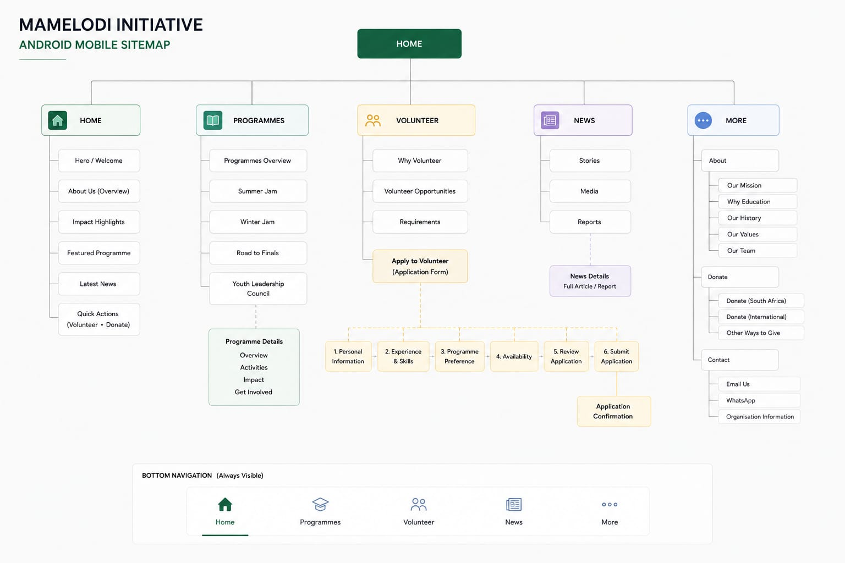
Figure 1 Mobile Application Sitemap

WEBSITE SITEMAP

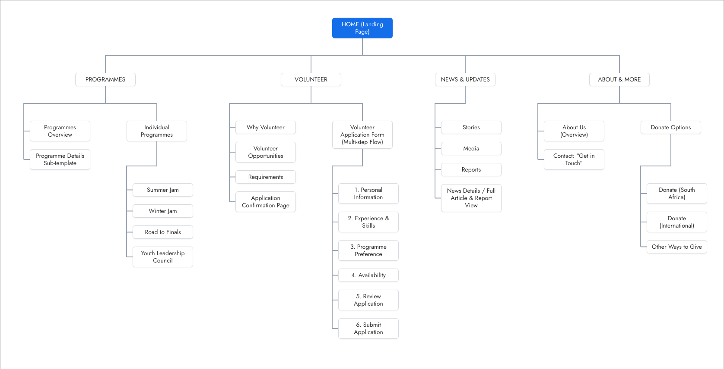
Figure 2 Website Sitemap

ANDROID MOBILE WIREFRAMES

Home and Programmes
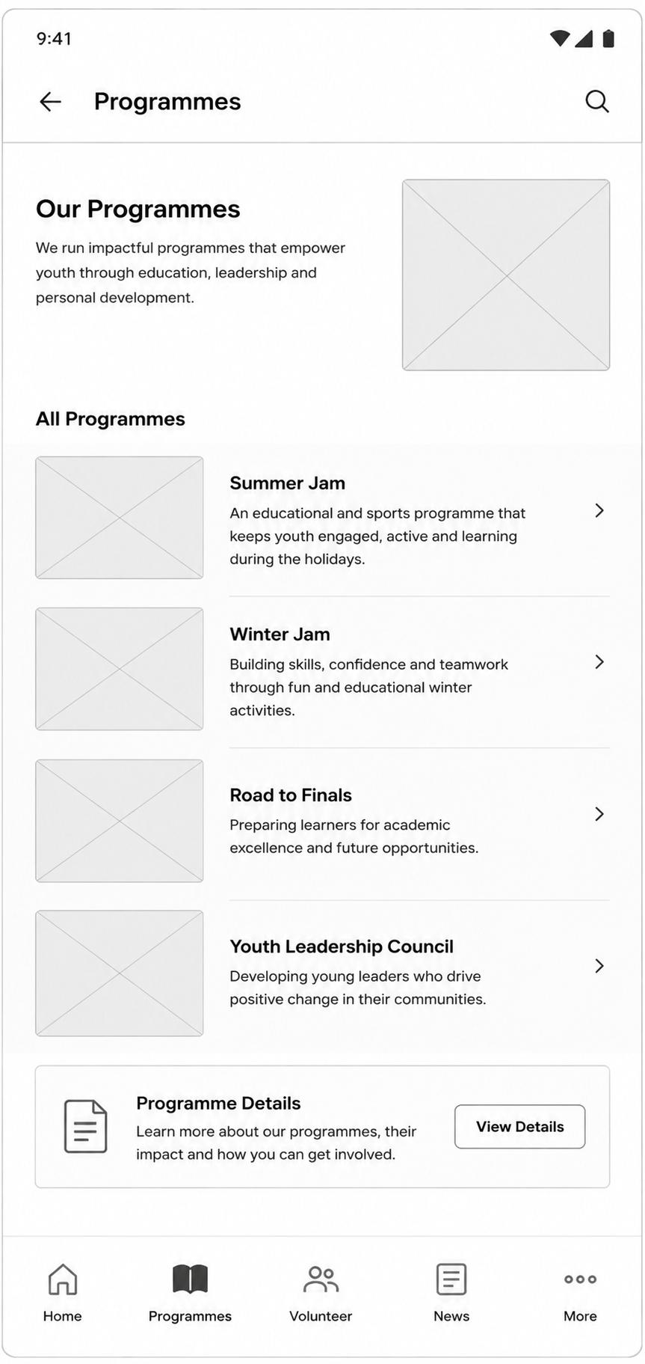
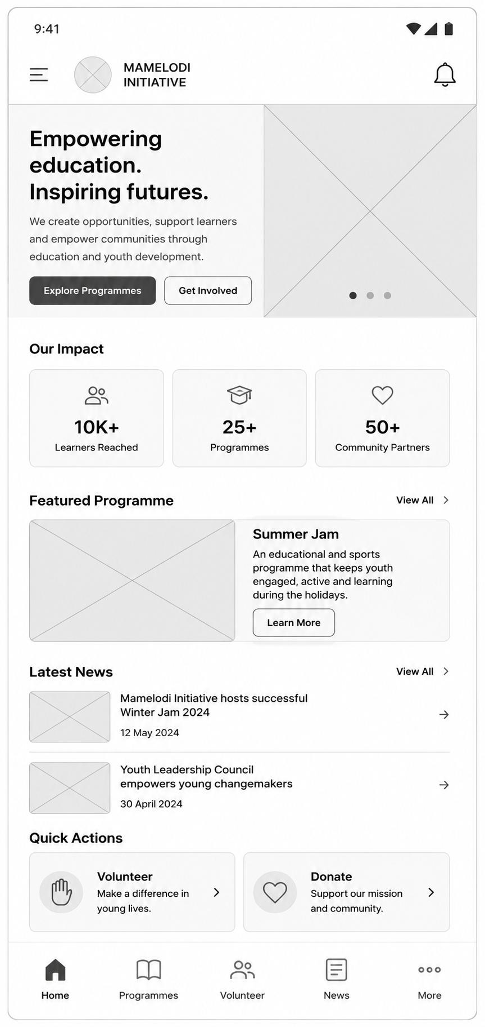

Figure 3 Home & Programs screens

Volunteer and News
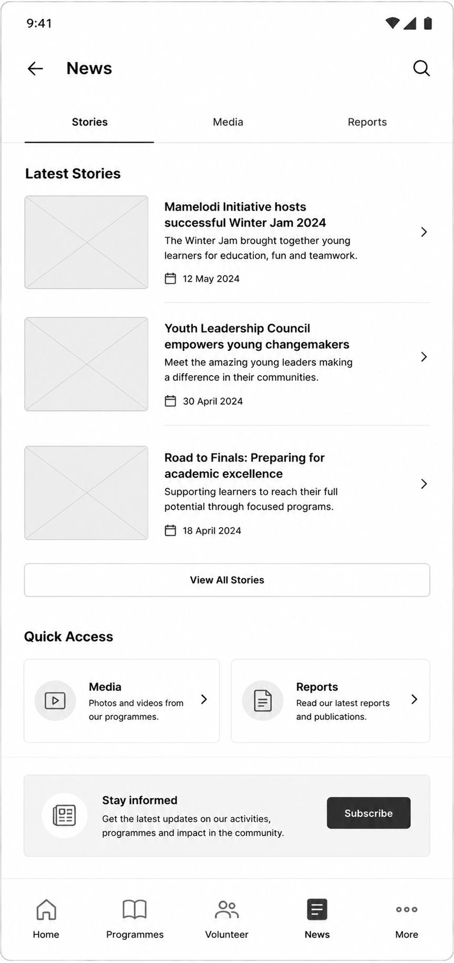
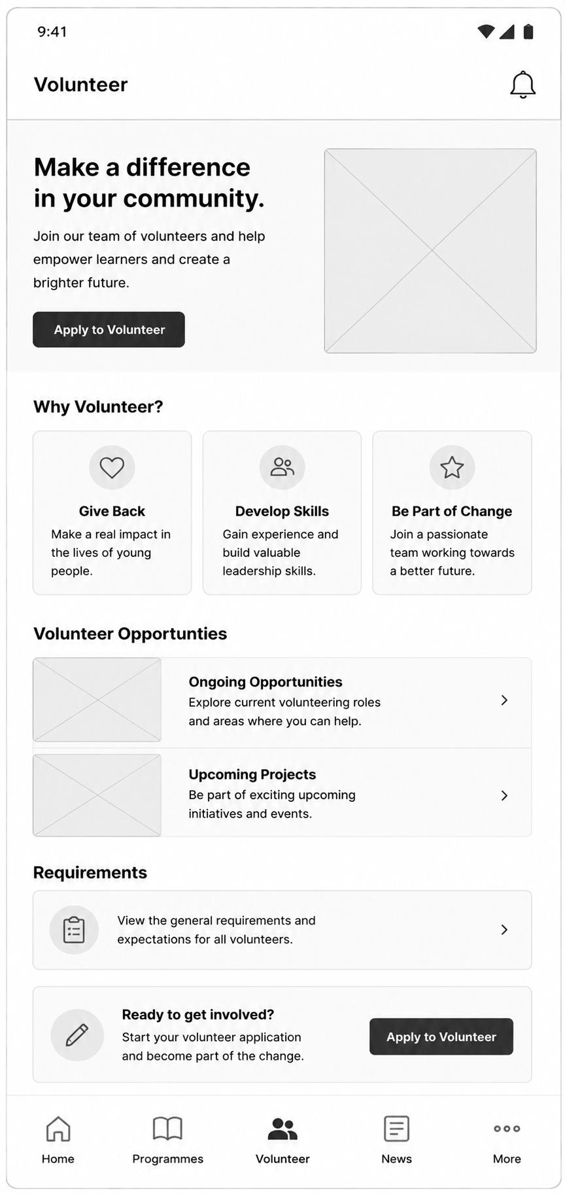

Figure 4 Volunteer & News screens

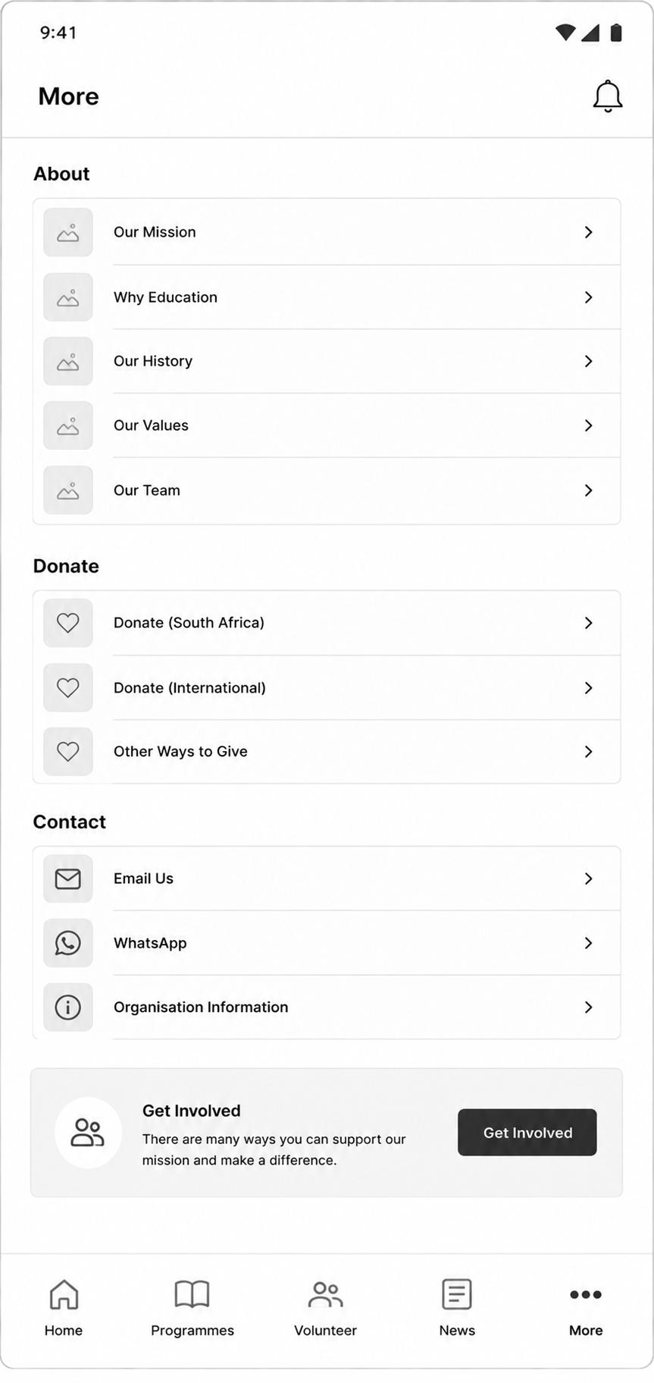

Figure 5 More options (About, Donate & Contact) screens

WEBSITE WIREFRAMES

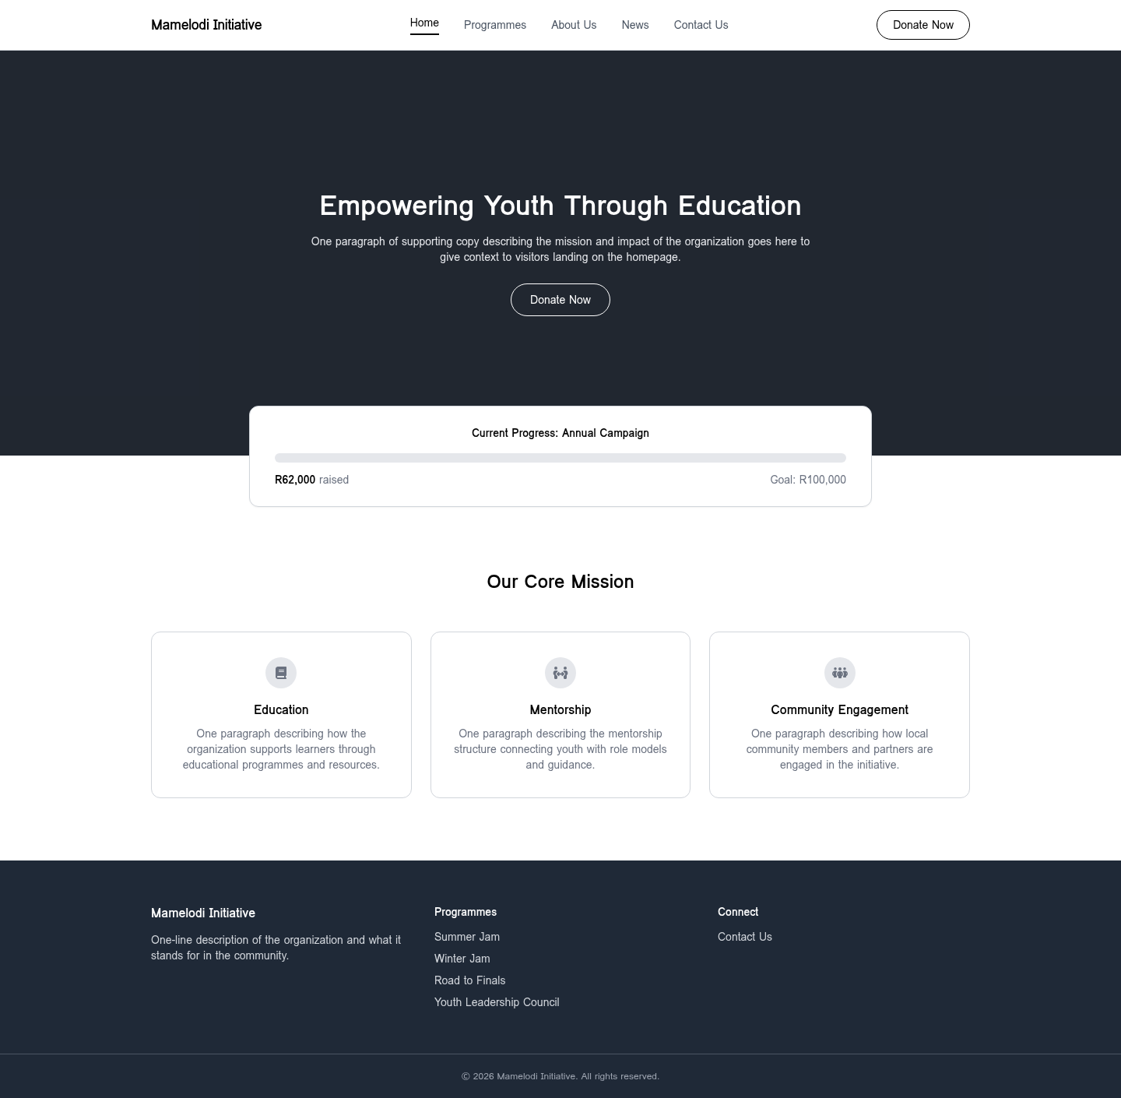
Figure 6 Home Page

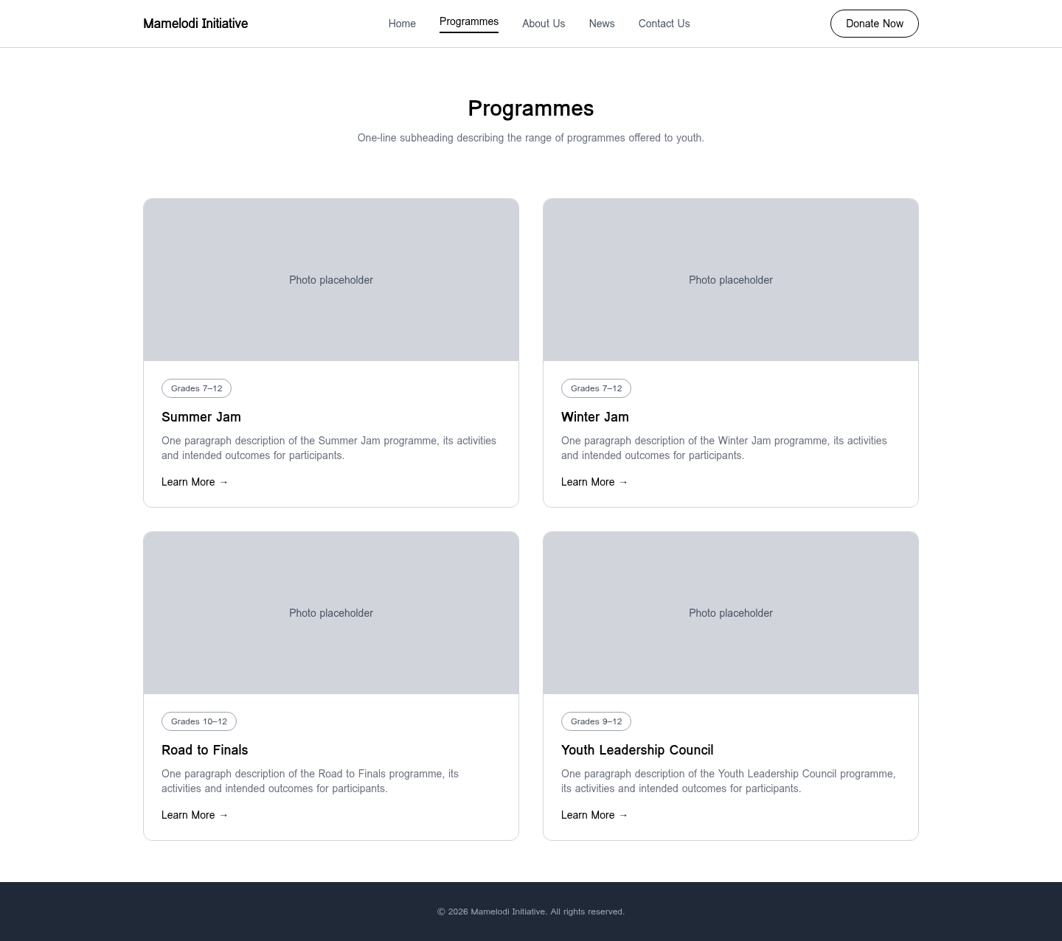
Figure 7 Programs Page

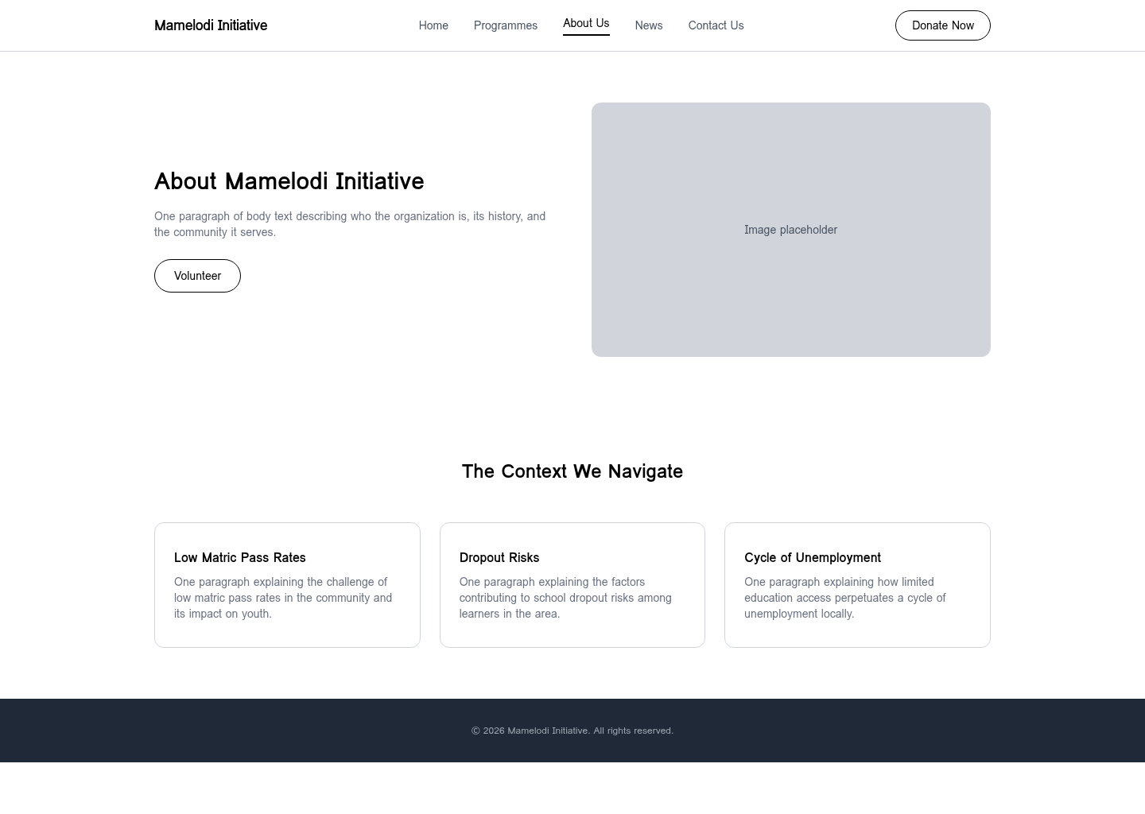
Figure 8 About Us Page

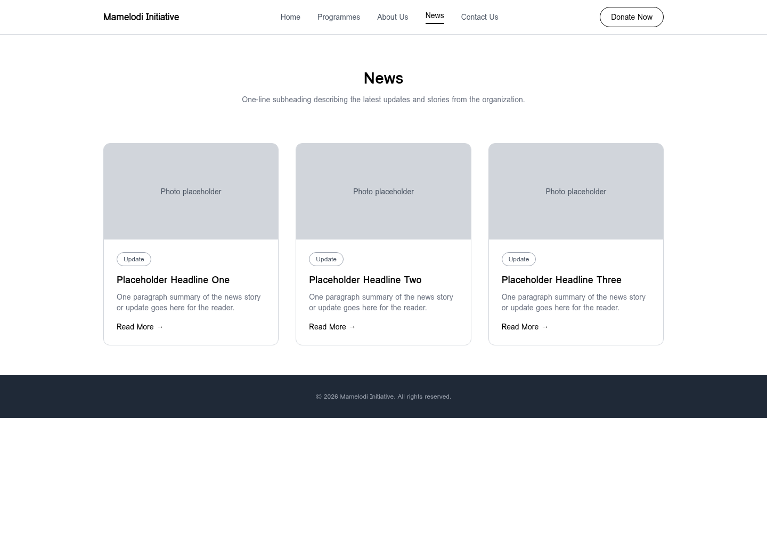
Figure 9 News page

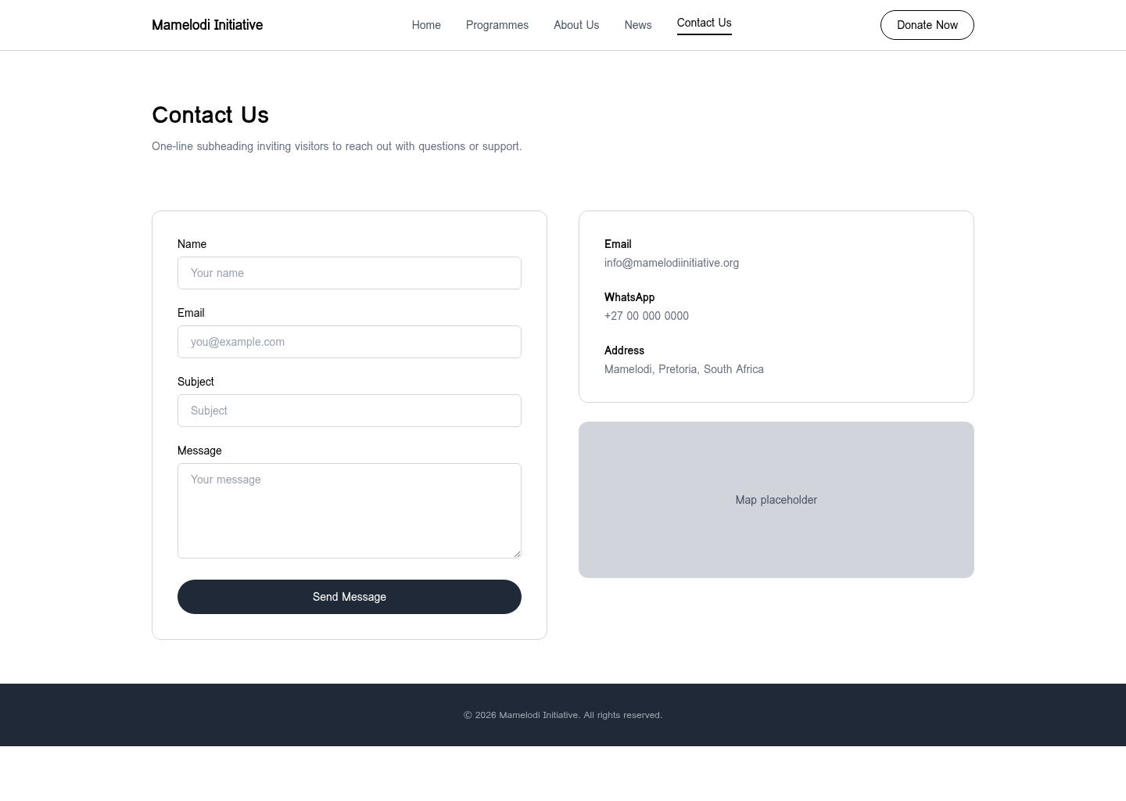
Figure 10 Contact us Page

References

- The Mamelodi Initiative. (n.d.) Our Mission. Available at: https://mamelodi.org/about/our-mission
[Accessed 4 September 2026].

- The Mamelodi Initiative. (n.d.) Our Programmes. Available at: https://mamelodi.org/programmes
[Accessed 4 September 2026].

- The Mamelodi Initiative. (2022) The Mamelodi Initiative Annual Report 2022 [PDF]. Available at: https://mamelodi.org/assets/files/2022-12-31_MI_Annual_Report_2022.pdf
[Accessed 4 September 2026].

- The Mamelodi Initiative. (2011) The Mamelodi Initiative Winter Program, Final Report 2011 [PDF]. Available at: https://mamelodi.org/assets/files/2011-07-31_MIWP11_Final_Report.pdf
[Accessed 4 September 2026].

- BackaBuddy. (n.d.) The Mamelodi Initiative (fundraising profile). Available at: https://www.backabuddy.co.za/organization/the-mamelodi-initiative
[Accessed 4 September 2026].

- LinkedIn. (n.d.) The Mamelodi Initiative (company page). Available at: https://www.linkedin.com/company/the-mamelodi-initiative
[Accessed 4 September 2026].

- Department of Basic Education, Republic of South Africa. (2023) National Senior Certificate (NSC) Examination Results 2022. Pretoria: DBE. Available at: https://www.education.gov.za
[Accessed 4 September 2026].

- Statistics South Africa. (2022) Census 2022: Key results on education and youth. Pretoria: Stats SA. Available at: https://www.statssa.gov.za
[Accessed 4 September 2026].

- Figma, Inc. (2026) Figma: The collaborative interface design tool [Online software]. Available at: https://www.figma.com
[Accessed 4 September 2026].

- GitHub, Inc. (2026) GitHub: Where the world builds software [Online platform]. Available at: https://github.com
[Accessed 4 September 2026].

